FairyTale Lib User Guide

**Authors (IV)**

### Peter Madaj (318307)

### Siddhartha Grasse (315278)

### Arturs Silins (315226)

### Ondrej Klimek (315255)

**SEP1**



#### VIA University College Software Technology Engineering

#### Supervisor

#### Date:08-08-2022

#### Word count:

1

**Contents**

1 Introduction 3

2 Importing Initial Data 4

3 Home 5

4 Costumers 6

4.1 Customer List 6

4.2 Add Customer 7

5 Items 8

5.1 Items List 8

5.2 Add Item 9

5.3 Search by title 10

6 Booking 11

7 Returning 12

8 Reserving 13

9 Warnings 14

# Introduction

#### Thank you for choosing to use FLS.

When we decided to make this FairyTale Library Software (FLS) we wanted it to be not just an another tool. Therefore we tried to make sure that using our software is both fun and elegant so that you will still want to use it even at the most stress full moment. FLS is power yet simple by design. It is advised for you to read this document before you start to use our software so you will get the best experience out of it. The document will provide you with the overview of what FLS is capable of and how to use it.

This software is created for Fairytale Village University Collage to help them to manage their local library. FLS is capable of managing customers, items in the library like books, articles, CDs, DVDs, borrowing items, returning items, reserving items and warnings for returning the item or paying fine for not returning by the return date. If you want any new feature or find a bug then please contact us on GitHub.

https://github.com/souracidko/FairyTale-Library-Software.git

# Importing Initial Data

The FairyTale Library Software (FLS) doesn’t have and easy way to initial data. If you choose to use

this Library Software you will need 2 things.

* + 1. First thing you will need is to create membership cards for your customers. Every customer needs to have unique ID for the software to work.
    2. Second thing you as a library will need to create a numbering system for all yours times. Every item in the library needs to have his own ID in the system and a sticker with this ID on the item.

When you have this 2 things you can start adding all the items to the program. Follow steps on page 9, step 5.2 as a tutorial to adding items to the software.

# 3 Home

After you open FairyTale Library it will present you with the customers list and 6 tabs in total.

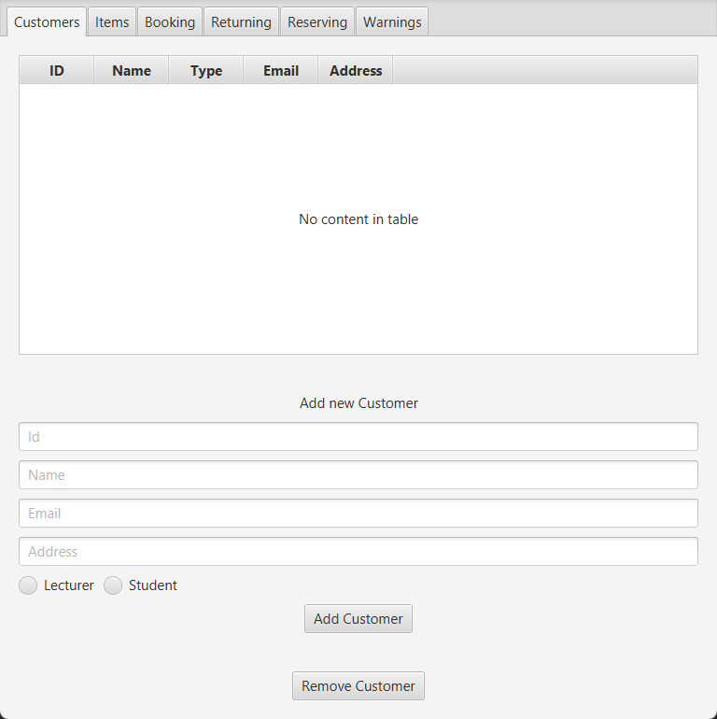

Figure 1: Home

There are 6 tabs in total, when clicking them will take you to a new window where you will be able to manage it.

**!IMPORTANT** you need to pick the correct tab to change the correct parameters

# Customers

After clicking on the customers tab it will bring you to customer list tab, where you can view all the customers in the customer list.

## Customer List

You have an option to remove the customer form the customer list. To remove the customer

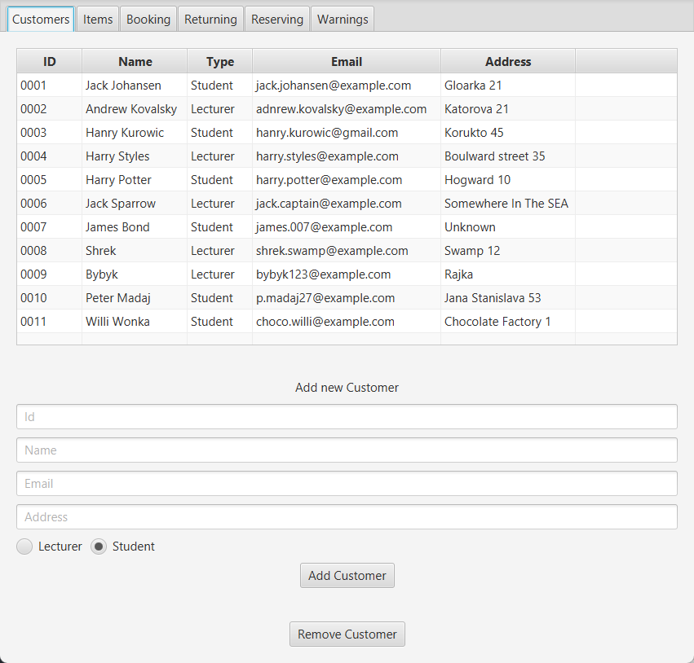

Figure 2: All Customers

* + 1. Click on the Customer you want to remove
    2. Click “Remove Customer”
    3. The selected Customer will be removed from the Customer List

## Add Customer

* + 1. Fill in the Id, Name, Email, Address
    2. Select on the radio button if the customer is Student or Lecturer
    3. Click “Add Customer”
    4. New Customer will be added to the Customer List

**!IMPORTANT** more than one Customer with the same ID’s cannot be created

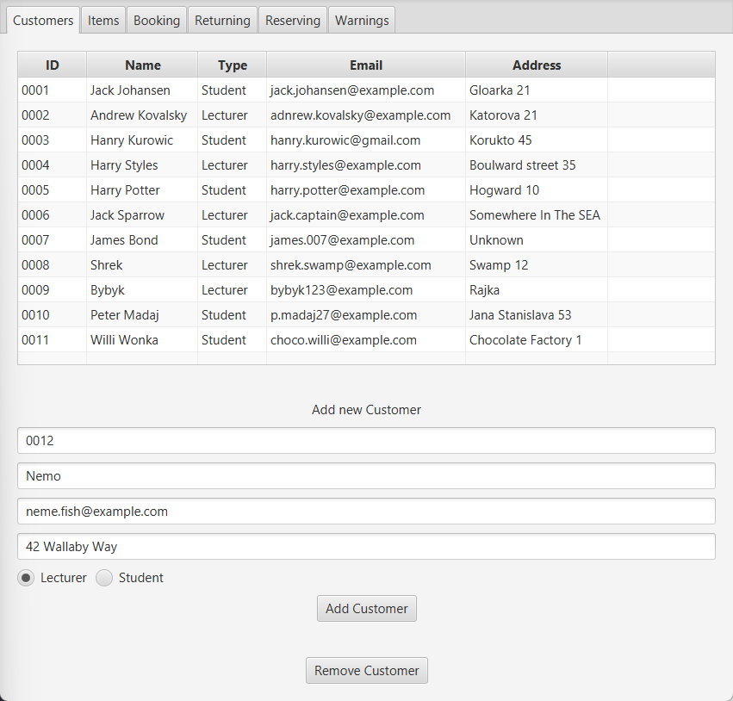

Figure 3: Add Customer

# Items

After clicking on the Items tab it will bring you to Item List page, where you can view all the Items in the Items List.

## Items List

Figure 4: All Items

You also have an option to remove the Item form the Items List. To remove the Item

* + 1. Click on the Item you want to remove
    2. Click “Remove Item”
    3. The Item will be removed from the Items List

In the Item List you can also see the borrow date and the return date and who borrowed the book, also who is the first in the reservation order.

## Add Item

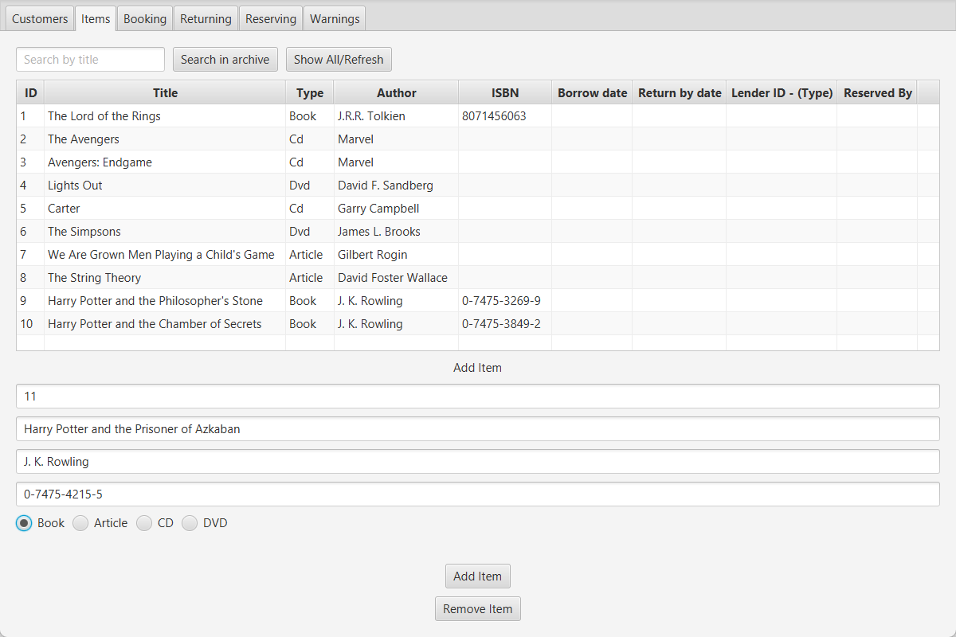

Figure 5: Add Item

* + 1. Fill in Id, Title, Author, ISBN (**!IMPORTANT** don’t fill in ISBN if you are not adding book)
    2. Select on the radio button if the Item is Book, Article, CD or DVD
    3. Click “Add Item”
    4. The Item will be added to the Item List
    5. Click “Show All/Refresh” to show all the items

**!IMPORTANT** more than one item with the same ID’s cannot be created

* 1. **Search by title**

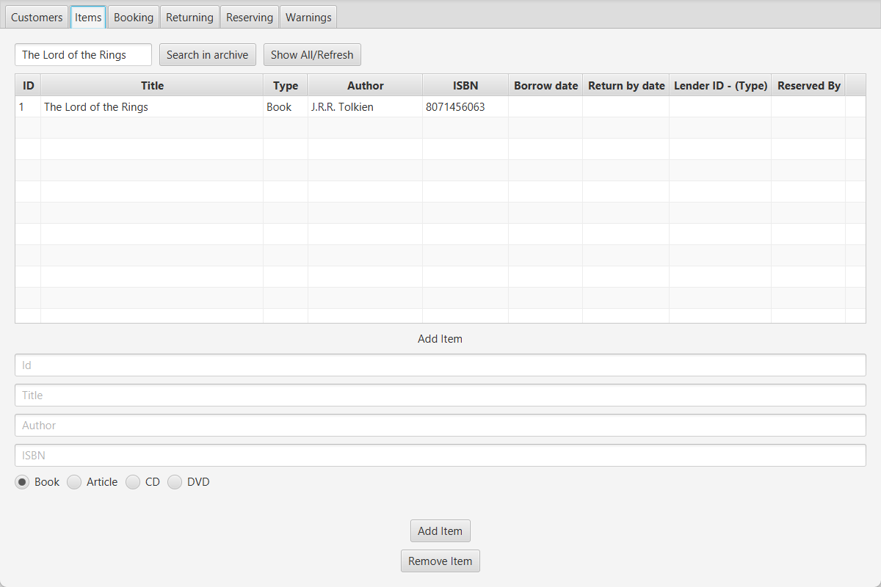

Figure 6: Add Item

* + 1. Type in the top left corner the Title of the item you are looking for
    2. Click “Search in archive”
    3. The list will show all the found items
    4. When you want to go back, click “Show all/Refresh”
    5. The list will go back to all items

# Booking

After clicking on the Booking tab it will bring you to Booking tab, where you create new bookings.

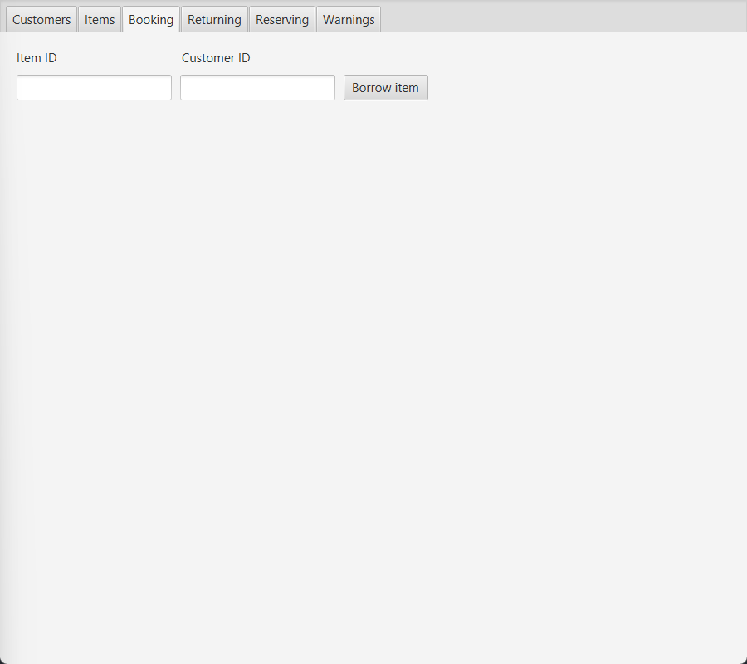

Figure 7: Create new Booking

1. Fill in the Id of the item that the customer wants to borrow
2. Fill in the Id of the customer that wants to borrow the item
3. Click “Borrow item”
4. The item will be borrowed to the customer with a message pop up “Item successfully booked”

# Returning

After clicking on the Returning tab it will take you to the returning tab, where you can return the items that customers bring back.

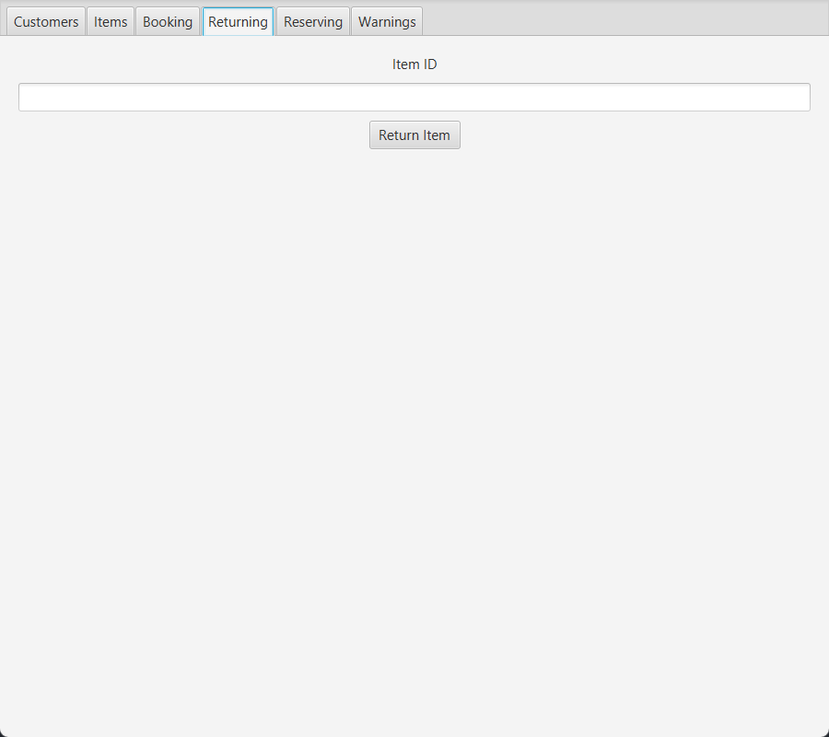

Figure 8: Returning

1. Fill in the Item Id
2. Click “Return Item”
3. Items is returned when pop up message “Successfully returned the item” displays on the monitor

**!IMPORTANT** when pop up message “Successfully returned, but pay the FINE” pop up, this customer needs to pay the fine for not bringing the item by the return date

# Reserving

After clicking on the Reserving tab it will bring you to Reserving tab, where you can create new reservations.

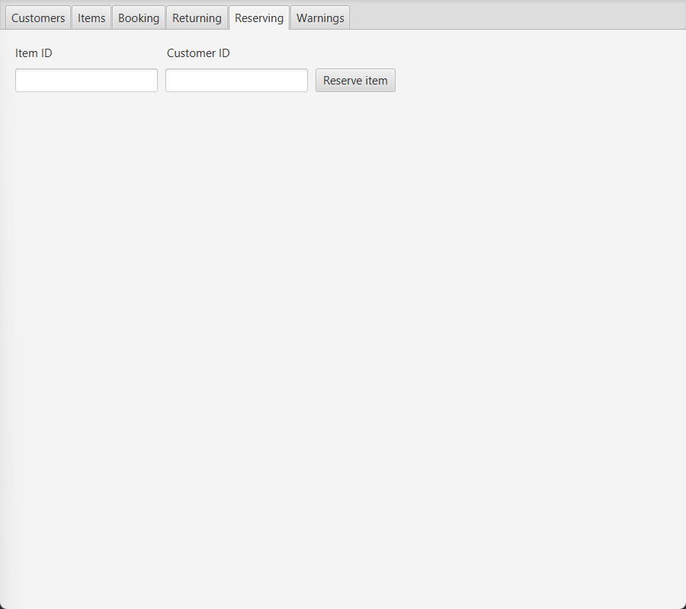

Figure 9: Reserving

1. Fill in the Id of the item the customer wants to reserve.
2. Fill in the Id of the customer that wants to reserve this item
3. Click “Reserve item” the item is reserved when pop up message “Item successfully reserved” with the number of customers that reserved this item before him/her.

**!IMPORTANT**  item that is free to book cannot be reserved, only booked. Also the same customer that has the item borrowed cannot reserve it, if this happens pop up massage “Customer cannot reserve book which he or she has currently lent”

## Warnings

After clicking on the Warnings tab it will bring you to Warnings tab, where you can find all the people that should be reminded to bring the borrowed item back and find all the people that should be .

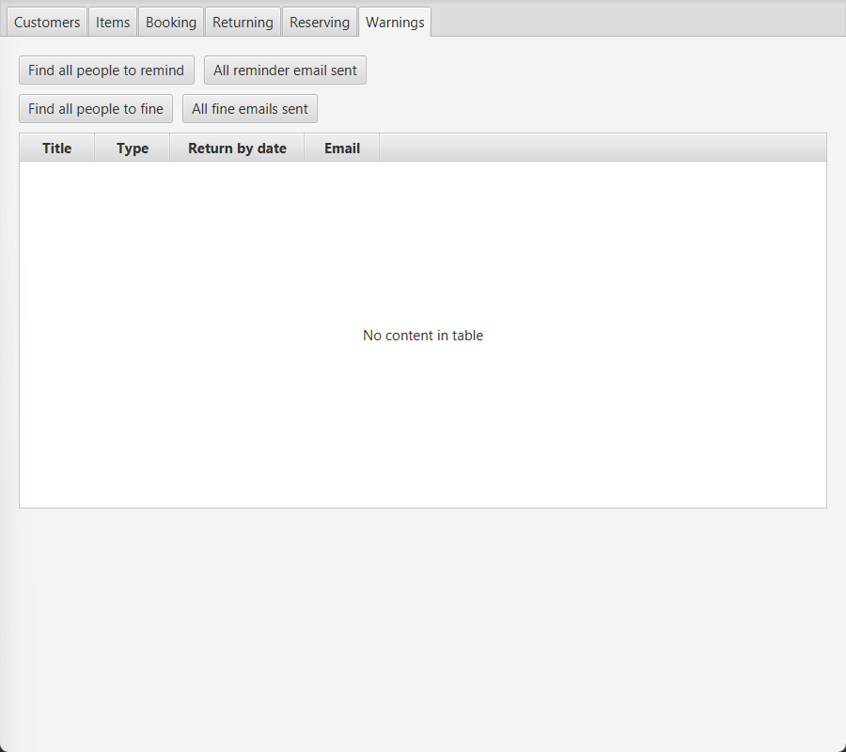

Figure 10: Warnings

1. If you want to find all people that should be reminded, click “Find all people to remind”
   1. After you send all the emails click “All reminder email sent” (only press this if you are 100% sure you sent all the email)
2. If you want to find all people that should get fined, click “Find all people to fine”
   1. After you send all the emails click “All fine emails sent” (only press this if you are 100% sure you sent all the emails)